Transport Organizer

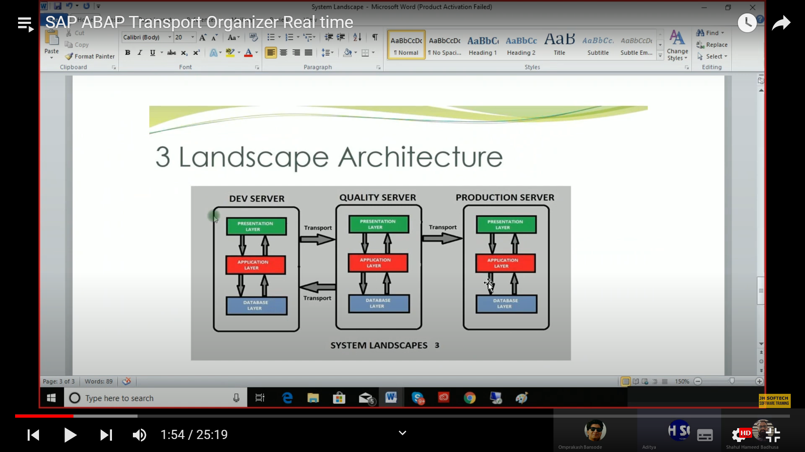

Local Object can not be moved from development -> Quality -> Production

Save it in package (se80 ABAP Workbench, se21 Package Creation)

SE09

Transport Organizer – Release the objects

Request Number

* Task Number

When we save a program, it will assign a request number.

Then it will be transportable.

To generate a request number, only by saving under a package.

An empty Request Number can be released.

You cannot release a request number directly without releasing their task number.

Task number should be generated by system automatically.

If two people are working on same request number, then their task number will be different.

The all tasks should be released first, before releasing the request number. It will not allow you to release the request task.

Once the task number and request number is released.

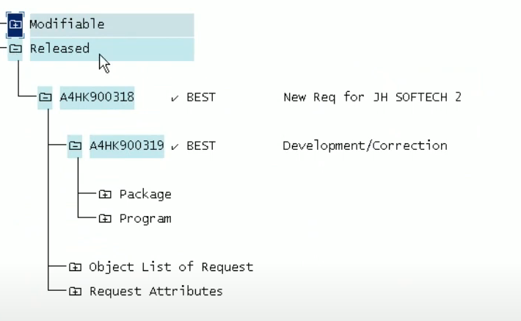

It will move from modifiable to released.